**MIDDLETON CHENEY FOOTBALL CLUB**

**ANNUAL GENERAL MEETING**

**1968**

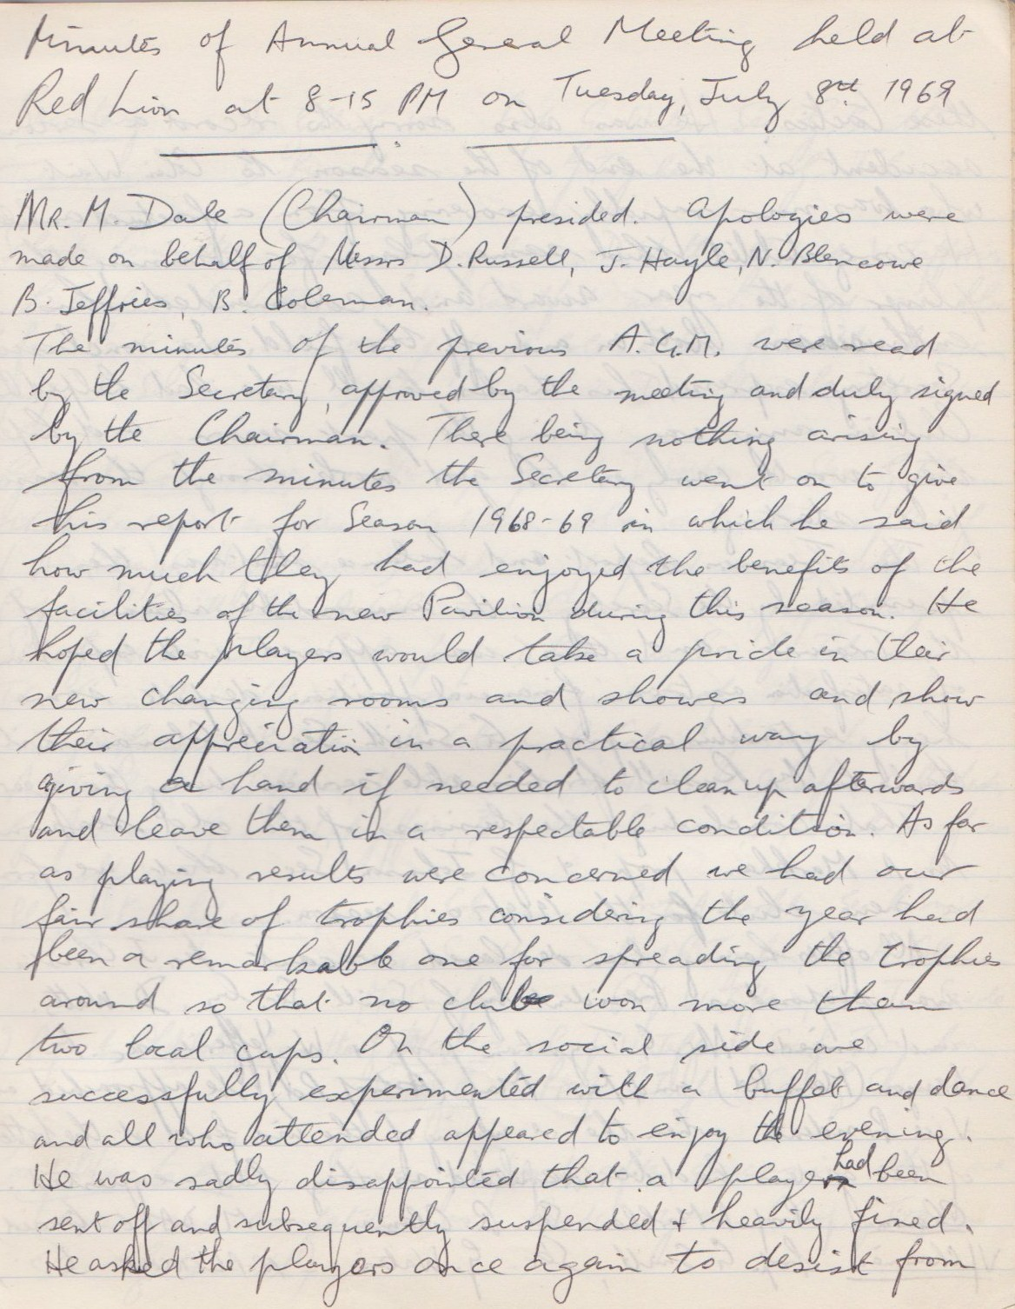

**Continued**

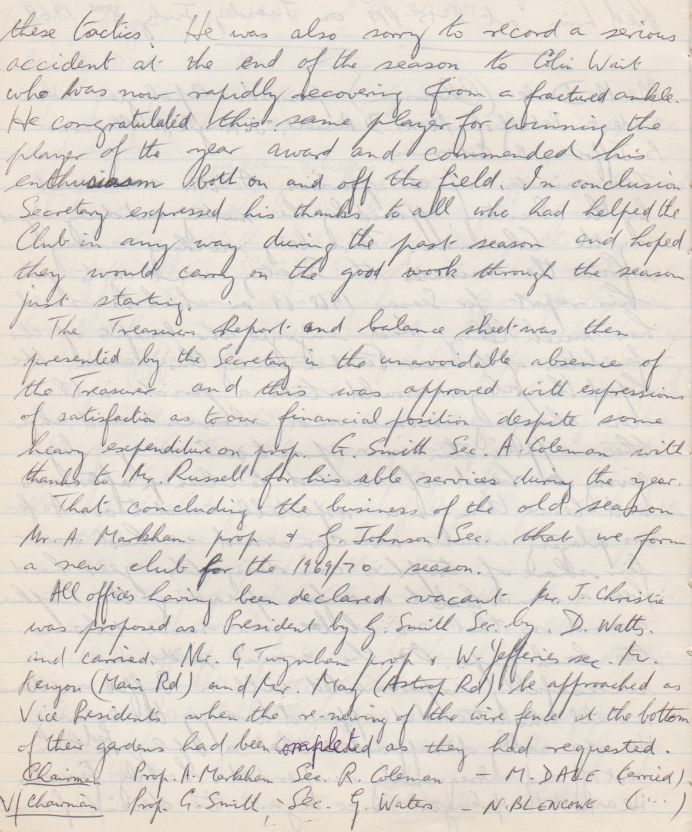

**Continued**

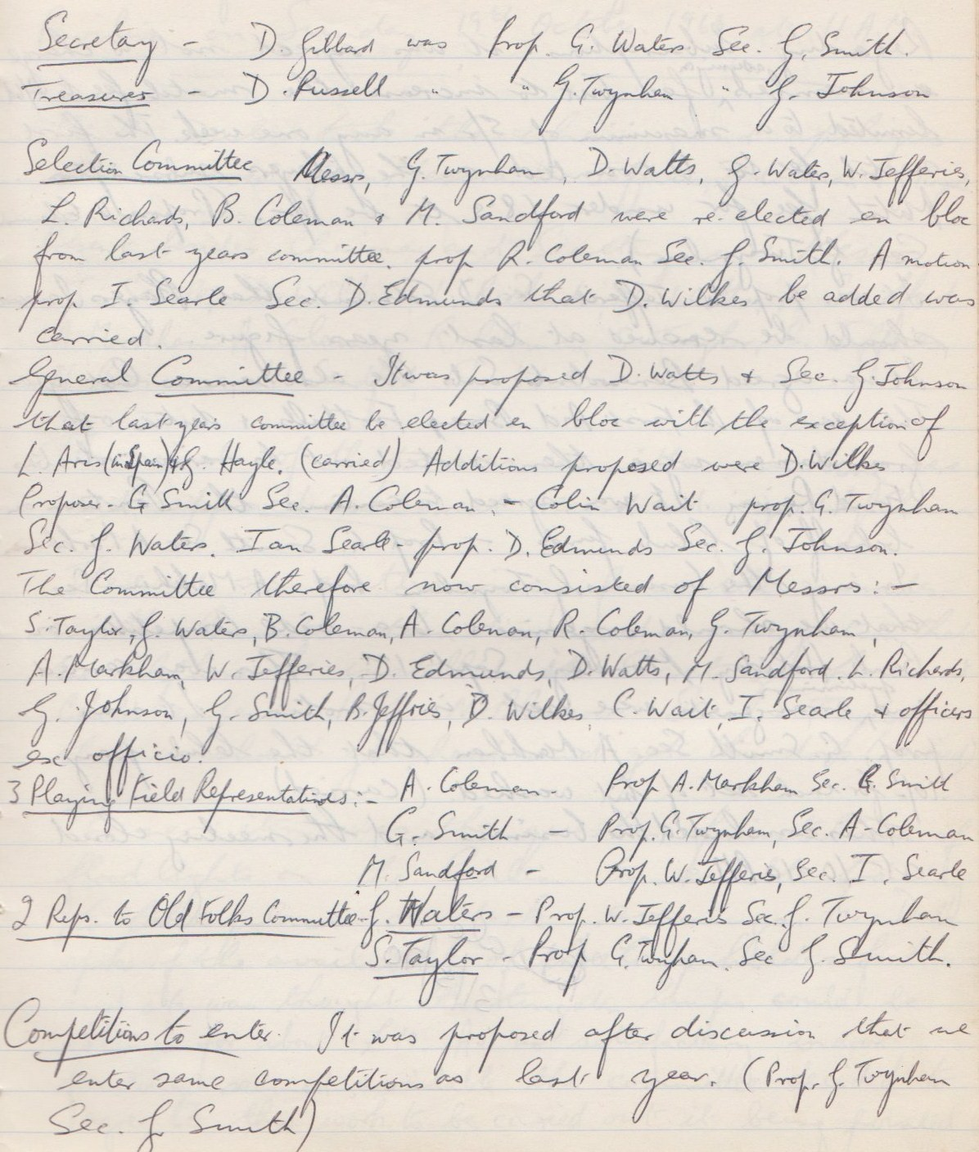

**Continued**

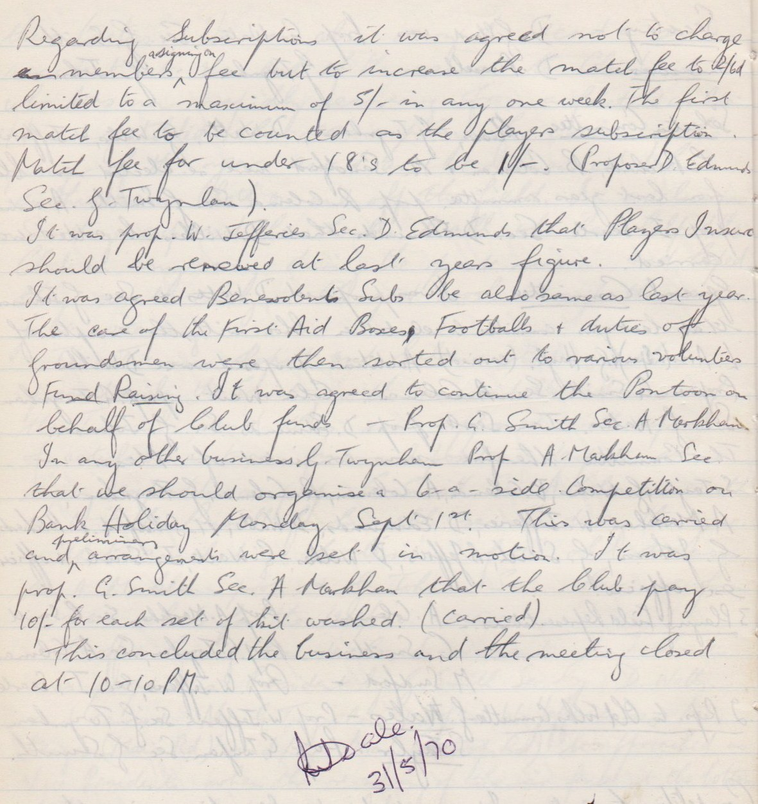

**General Committee Meeting**

**October 19th 1969**

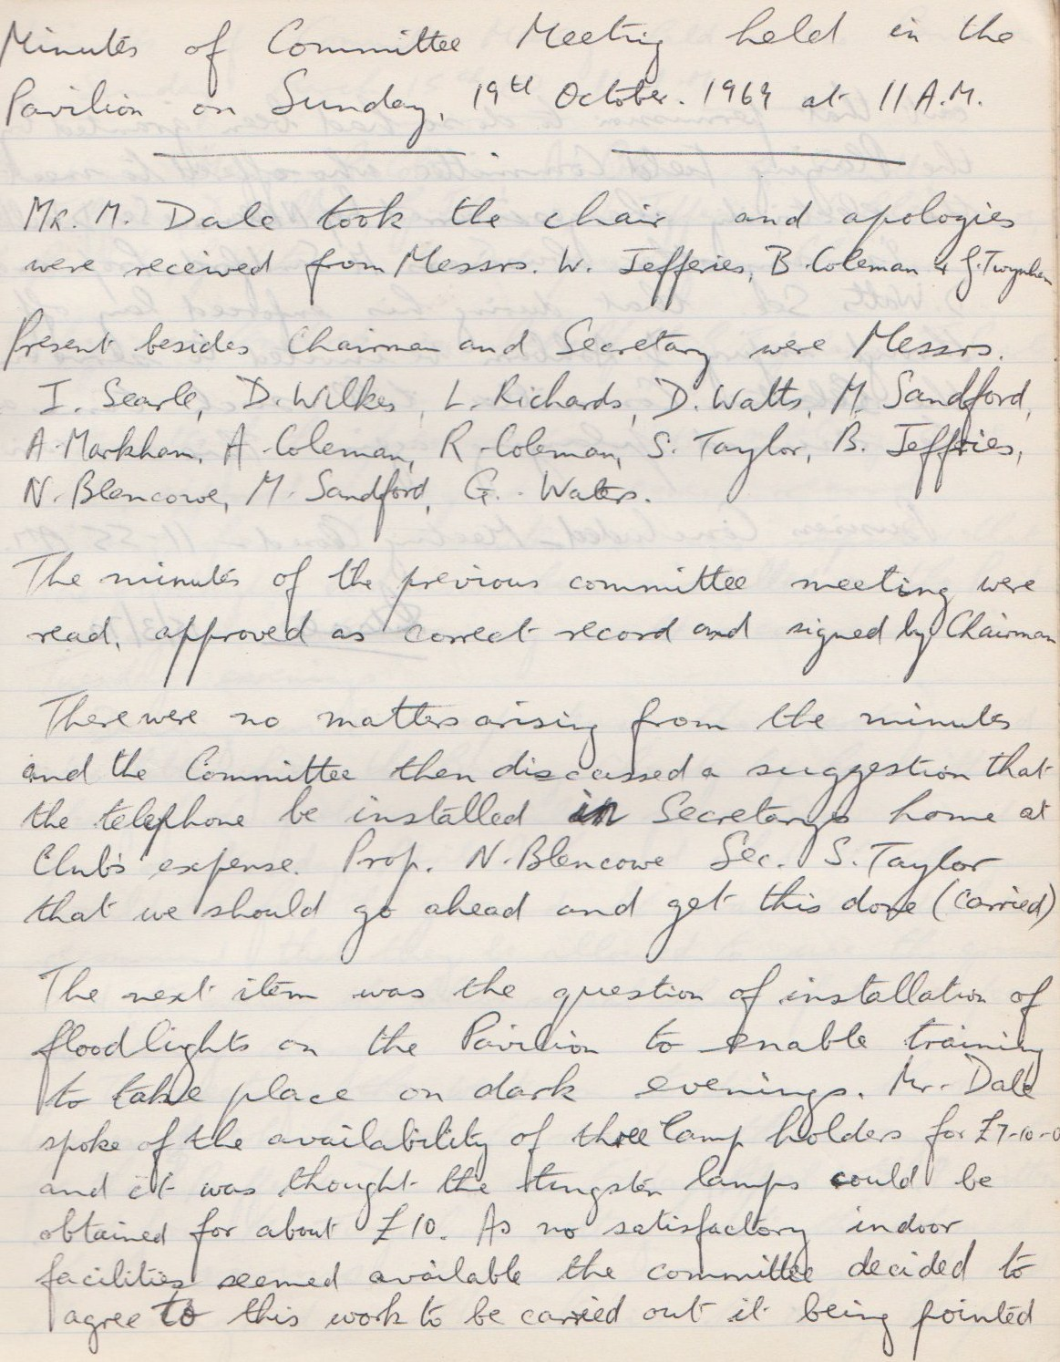

**Continued**

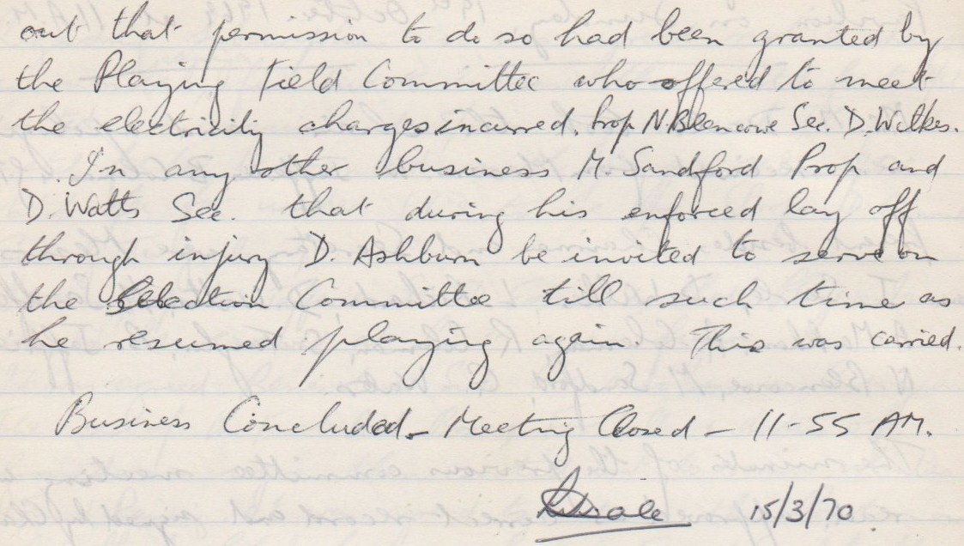

**General Committee Meeting**

**March 15th 1970**

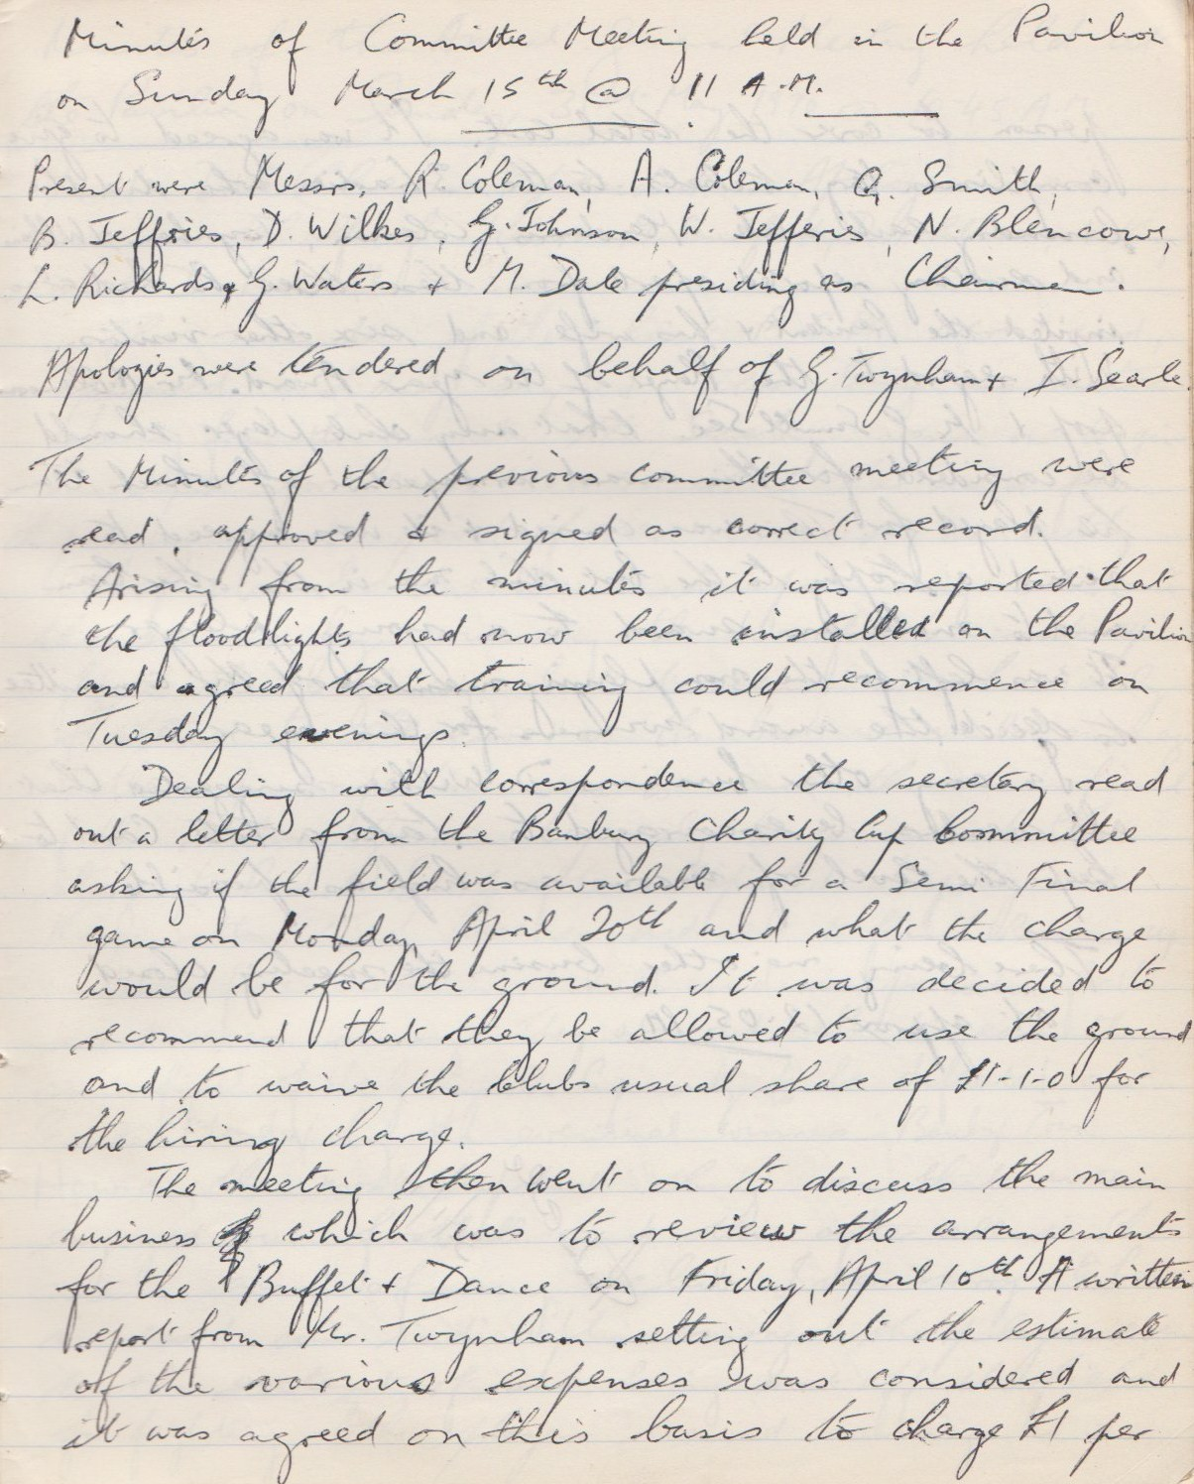

**Continued**

